Chapter 4: Single-Table Queries
Solutions
Answers to Review Questions
1. The basic form of the SELECT command is SELECT-FROM. Specify the columns to be listed after the word SELECT (or type * to select all columns), and then specify the table name that contains these columns after the word FROM. Optionally, you can include conditions after the word WHERE.
2. Simple conditions are written in the form: column name, comparison operator, column name or value. Simple conditions can involve any of the comparison operators: =, >, >=, <, <=, or < > or != (not equal to).
3. You can form compound conditions by combining simple conditions, using the operators AND, OR, or NOT.
4. Use the BETWEEN operator.
5. Use arithmetic operators and write the computation in place of a column name. You can assign a name to the computation by following the computation with the word AS and then the desired name.
6. To check for a value in a character column that is similar to a particular string of characters, use the LIKE clause. The percent (%) wildcard represents any collection of characters. The underscore (_) wildcard represents any single character.
7. In Oracle, the percent (%) wildcard represents any collection of characters. The underscore (_) wildcard represents any single character.
8. Use the IN clause.
9. Use the ORDER BY clause to sort data.
10. List the sort keys in order of importance in the ORDER BY clause. The more important key is called the major key or the primary sort key. The less important key is called the minor key or the secondary sort key.
11. To sort in descending order, follow the sort key with DESC.
12. The aggregate functions are COUNT, SUM, AVG, MAX, and MIN.
13. To avoid duplicates, precede the column name with the DISTINCT operator.
14. One SQL query that is placed inside another. It is evaluated before the outer query.
15. Use the GROUP BY clause.
16. Use the HAVING clause.
17. Use the phrase IS NULL in the WHERE clause.
18. [Critical Thinking]
SELECT CUSTOMER_NAME, CITY
FROM CUSTOMER
WHERE CITY LIKE '[CG]%';

Answers to TAL Distributors Exercises
1.
SELECT ITEM_NUM, DESCRIPTION, PRICE
FROM ITEM;
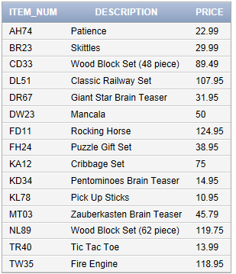

2.
SELECT *
FROM ORDERS;
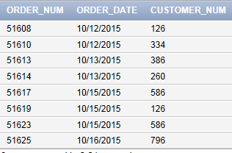

3.
SELECT CUSTOMER_NAME
FROM CUSTOMER
WHERE CREDIT_LIMIT >= 10000;
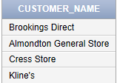

4.
SELECT ORDER_NUM
FROM ORDERS
WHERE CUSTOMER_NUM = '126'
AND ORDER_DATE = '10/15/2015';
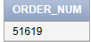

In Access, the command would be:
SELECT ORDER_NUM
FROM ORDERS
WHERE CUSTOMER_NUM = '126'
AND ORDER_DATE = #10/15/2015#;

5.
SELECT CUSTOMER_NUM, CUSTOMER_NAME
FROM CUSTOMER
WHERE REP_NUM = '30'
OR REP_NUM = '45';
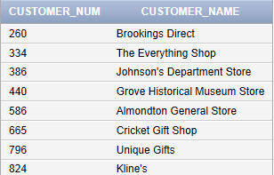

6.
SELECT ITEM_NUM, DESCRIPTION
FROM ITEM
WHERE NOT (CATEGORY = 'PZL');
or
SELECT ITEM_NUM, DESCRIPTION
FROM ITEM
WHERE CATEGORY <> 'PZL';
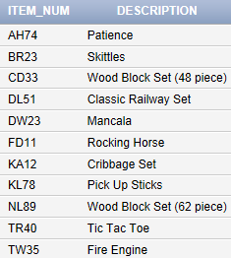

7.
SELECT ITEM_NUM, DESCRIPTION, ON_HAND
FROM ITEM
WHERE ON_HAND >= 20
AND ON_HAND <= 40;

or
SELECT ITEM_NUM, DESCRIPTION, ON_HAND
FROM ITEM
WHERE ON_HAND BETWEEN 20 AND 40;
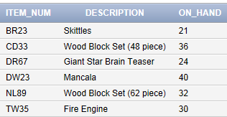

8.
SELECT ITEM_NUM, DESCRIPTION, ON_HAND * PRICE AS ON_HAND_VALUE
FROM ITEM
WHERE CATEGORY = 'TOY';
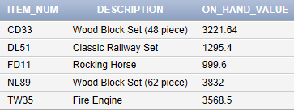

9.
SELECT ITEM_NUM, DESCRIPTION, ON_HAND * PRICE AS ON_HAND_VALUE
FROM ITEM
WHERE ON_HAND * PRICE >= 1500;
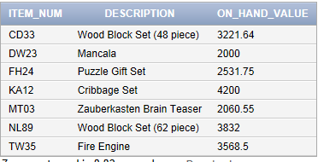

10.
SELECT ITEM_NUM, DESCRIPTION
FROM ITEM
WHERE CATEGORY IN ('GME', 'PZL');
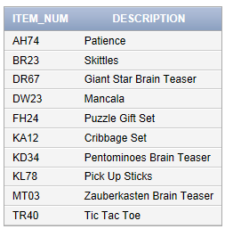

11.
In Oracle and SQL Server:
SELECT CUSTOMER_NUM, CUSTOMER_NAME
FROM CUSTOMER
WHERE CUSTOMER_NAME LIKE 'C%';

In Access:
SELECT CUSTOMER_NUM, CUSTOMER_NAME
FROM CUSTOMER
WHERE CUSTOMER_NAME LIKE “C*”';
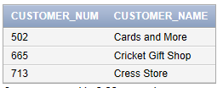

12.
SELECT *
FROM ITEM
ORDER BY DESCRIPTION;
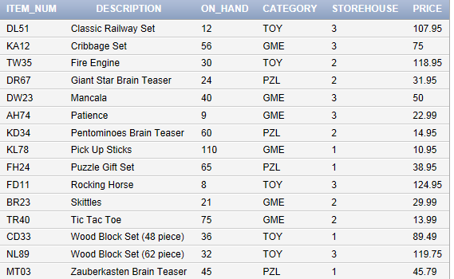

13.
SELECT *
FROM ITEM
ORDER BY STOREHOUSE, ITEM_NUM;
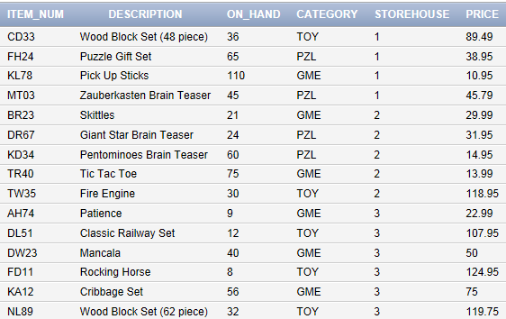

14.
SELECT COUNT(*)
FROM CUSTOMER
WHERE BALANCE > CREDIT_LIMIT;
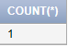

15.
SELECT SUM(BALANCE)
FROM CUSTOMER
WHERE REP_NUM = '15'
AND BALANCE < CREDIT_LIMIT;
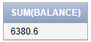

16.
SELECT ITEM_NUM, DESCRIPTION, ON_HAND
FROM ITEM
WHERE ON_HAND >
(SELECT AVG(ON_HAND)
FROM ITEM);
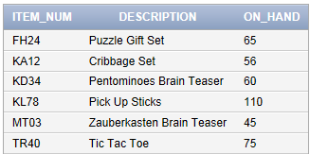

17.
SELECT MIN(PRICE)
FROM ITEM;
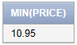

18.
SELECT ITEM_NUM, DESCRIPTION, PRICE
FROM ITEM
WHERE PRICE =
(SELECT MIN(PRICE)
FROM ITEM);
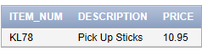

19.
SELECT REP_NUM, SUM(BALANCE)
FROM CUSTOMER
GROUP BY REP_NUM
ORDER BY REP_NUM;
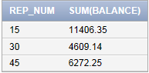

20.
SELECT REP_NUM, SUM(BALANCE)
FROM CUSTOMER
GROUP BY REP_NUM
HAVING SUM(BALANCE) > 5000
ORDER BY REP_NUM;
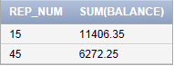

21.
SELECT ITEM_NUM
FROM ITEM
WHERE DESCRIPTION IS NULL;
no data found

22. [Critical Thinking]
In Oracle and SQL Server
SELECT * FROM ITEM
WHERE DESCRIPTION LIKE '%Set%'
AND CATEGORY IN ('PZL','TOY');

In Access
SELECT * FROM ITEM
WHERE DESCRIPTION LIKE '*Set*'
AND CATEGORY IN ('PZL','TOY');
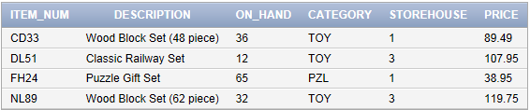

23. [Critical Thinking]
SELECT ITEM_NUM, DESCRIPTION, .9*PRICE AS DISCOUNTED_PRICE
FROM ITEM;
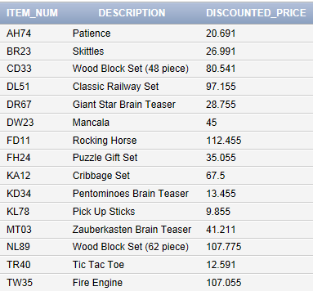

Answers to Colonial Adventure Tours Exercises
1.
SELECT LAST_NAME
FROM GUIDE
WHERE STATE <> 'MA';
Or
SELECT LAST_NAME
FROM GUIDE
WHERE NOT STATE = 'MA';
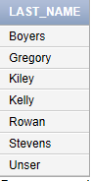

2.
SELECT TRIP_NAME
FROM TRIP
WHERE TYPE = 'Biking';
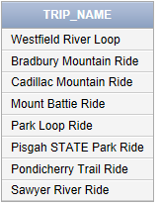

3.
SELECT TRIP_NAME
FROM TRIP
WHERE SEASON = 'Summer';
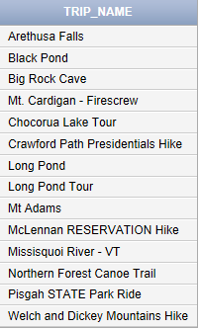

4.
SELECT TRIP_NAME
FROM TRIP
WHERE TYPE = 'Hiking'
AND DISTANCE >10;
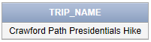

5.
SELECT CUSTOMER_NUM, LAST_NAME, FIRST_NAME
FROM CUSTOMER
WHERE STATE IN ('NJ', 'NY', 'PA');
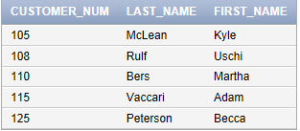

6.
SELECT CUSTOMER_NUM, LAST_NAME, FIRST_NAME
FROM CUSTOMER
WHERE STATE IN ('NJ', 'NY', 'PA')
ORDER BY STATE DESC, LAST_NAME;
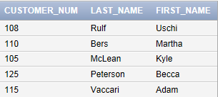

7.
SELECT COUNT(*)
FROM TRIP
WHERE STATE IN ('ME','MA');
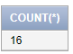

8.
SELECT STATE, COUNT(TRIP_ID)
FROM TRIP
GROUP BY STATE
ORDER BY STATE;
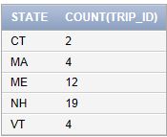

9.
SELECT COUNT(TRIP_PRICE)
FROM RESERVATION
WHERE TRIP_PRICE > 20 AND TRIP_PRICE < 75;
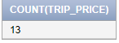

10.
SELECT TYPE, COUNT(TRIP_ID)
FROM TRIP
GROUP BY TYPE
ORDER BY TYPE;
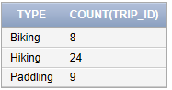

11.
SELECT RESERVATION_ID, TRIP_ID, CUSTOMER_NUM, (TRIP_PRICE+OTHER_FEES)*NUM_PERSONS AS TOTAL_PRICE
FROM RESERVATION
WHERE NUM_PERSONS > 4;
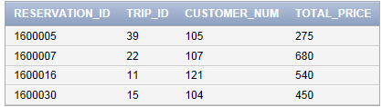

12.
In Oracle and SQL Server:
SELECT TRIP_NAME
FROM TRIP
WHERE TRIP_NAME LIKE '%Pond%';

In Access:
SELECT TRIP_NAME
FROM TRIP
WHERE TRIP_NAME LIKE '*Pond*';
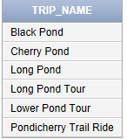

13.
In Oracle and SQL Server
SELECT LAST_NAME, FIRST_NAME
FROM GUIDE
WHERE HIRE_DATE < '6/10/2013';

In Access
SELECT LAST_NAME, FIRST_NAME
FROM GUIDE
WHERE HIRE_DATE < #6/10/2013#;
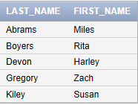

14.
SELECT TYPE, AVG(DISTANCE), AVG(MAX_GRP_SIZE)
FROM TRIP
GROUP BY TYPE
ORDER BY TYPE;
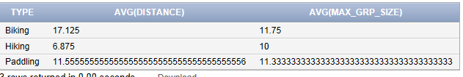

15.
SELECT DISTINCT(SEASON)
FROM TRIP;
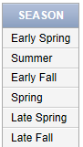

16.
SELECT RESERVATION_ID
FROM RESERVATION
WHERE TRIP_ID IN
(SELECT TRIP_ID
FROM TRIP
WHERE TYPE = 'Paddling');
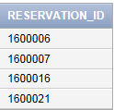

17.
SELECT MAX(DISTANCE)
FROM TRIP
WHERE TYPE = 'Biking';
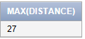

18.
SELECT TRIP_ID, SUM(TRIP_PRICE)
FROM RESERVATION
GROUP BY TRIP_ID
HAVING COUNT(*) > 1
ORDER BY TRIP_ID;
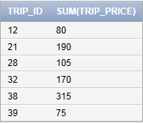

19.
SELECT COUNT(*), SUM(NUM_PERSONS)
FROM RESERVATION;
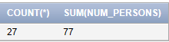

20. [Critical Thinking]
In Oracle and SQL two alternates are
SELECT RESERVATION_ID, TRIP_ID
FROM RESERVATION
WHERE TRIP_DATE BETWEEN '7/1/2016' AND '7/31/2016';

Or

SELECT RESERVATION_ID, TRIP_ID
FROM RESERVATION
WHERE TRIP_DATE >= '7/1/2016' AND TRIP_DATE <= '7/31/2016';

In Access the alternates are
SELECT RESERVATION_ID, TRIP_ID
FROM RESERVATION
WHERE TRIP_DATE BETWEEN #7/1/2016# AND #7/31/2016#;

Or

SELECT RESERVATION_ID, TRIP_ID
FROM RESERVATION
WHERE TRIP_DATE >= #7/1/2016# AND TRIP_DATE <= #7/31/2016#;
Note: You also can search for >6/30/2016 and < 8/1/2016 in Oracle, SQL Server, and Access.
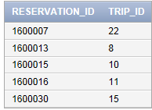

Answers to Solmaris Condominium Group Exercises
1.
SELECT OWNER_NUM, LAST_NAME, FIRST_NAME
FROM OWNER;
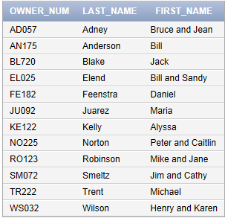

2.
SELECT *
FROM LOCATION;
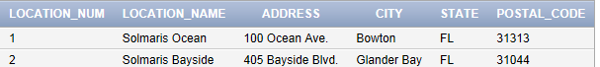

3.
SELECT LAST_NAME, FIRST_NAME
FROM OWNER
WHERE CITY = 'Bowton';
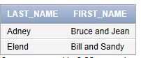

4.
SELECT LAST_NAME, FIRST_NAME
FROM OWNER
WHERE CITY <> 'Bowton';
or
SELECT LAST_NAME, FIRST_NAME
FROM OWNER
WHERE NOT (CITY = 'Bowton');
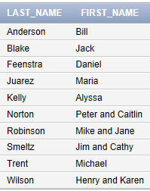

5.
SELECT LOCATION_NUM, UNIT_NUM
FROM CONDO_UNIT
WHERE SQR_FT <= 1200;
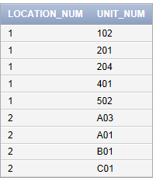

6.
SELECT LOCATION_NUM, UNIT_NUM
FROM CONDO_UNIT
WHERE BDRMS = 3;
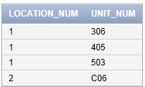

7.
SELECT UNIT_NUM
FROM CONDO_UNIT
WHERE BDRMS = 2
AND LOCATION_NUM = 2;
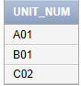

8.
SELECT CONDO_ID
FROM CONDO_UNIT
WHERE CONDO_FEE BETWEEN 550 AND 650;
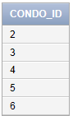

9.
SELECT UNIT_NUM
FROM CONDO_UNIT
WHERE LOCATION_NUM = 1
AND CONDO_FEE < 500;
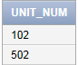

10.
SELECT CONDO_ID, CATEGORY_NUM, EST_HOURS, 35*EST_HOURS AS ESTIMATED_COST
FROM SERVICE_REQUEST;
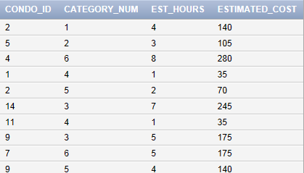

11.
SELECT OWNER_NUM, LAST_NAME
FROM OWNER
WHERE STATE IN ('FL', 'GA', 'SC');
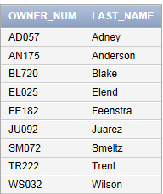

12.
SELECT LOCATION_NUM, UNIT_NUM, SQR_FT, CONDO_FEE
FROM CONDO_UNIT
ORDER BY SQR_FT, CONDO_FEE;
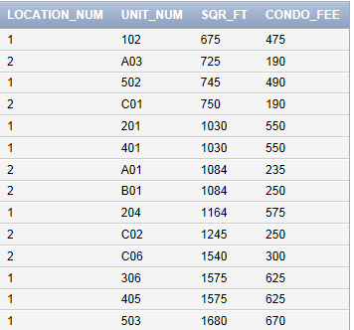

13.
SELECT COUNT(CONDO_ID)
FROM CONDO_UNIT
WHERE BDRMS = 1
GROUP BY LOCATION_NUM
ORDER BY LOCATION_NUM;
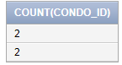

14.
SELECT SUM(CONDO_FEE)
FROM CONDO_UNIT;
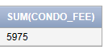

15. [Critical Thinking]
SELECT OWNER_NUM, LAST_NAME
FROM OWNER
WHERE STATE IN ('FL', 'GA', 'SC');

Or

SELECT OWNER_NUM, LAST_NAME
FROM OWNER
WHERE STATE = 'FL'
OR STATE = 'GA'
OR STATE = 'SC';

16. [Critical Thinking]
In Oracle and SQL Server
SELECT *
FROM SERVICE_REQUEST
WHERE DESCRIPTION LIKE '%pantry%';

In Access
SELECT *
FROM SERVICE_REQUEST
WHERE DESCRIPTION LIKE '*pantry*';

